Stabilization Team Playbook

|  |  |  |  |
| --- | --- | --- | --- |
| **Version** | **Date** | **Author** | **Change** |
| 0.1 | 1/20/2026 | Naveen Kumar Nammi, Ravinder Nalluri | Draft Version |
| 1.0 |  | Anila Thomas | Document Review |
|  |  |  |  |

Table of Contents

1. Introduction 4

2. Team Structure & Roles 4

Team Chart 4

Roles and Responsibilities 4

3. Operating Model 5

Work Intake Model 6

Scope Of Work 6

Hotfix Release 7

Regular Release 8

Work Locations & Support Timing 8

Meeting Cadence 8

4. Core Processes & SOPs 9

4.1 Incident Management SOP 9

1. Detection & Logging 9

2. Triage & Prioritization 12

3. SLA for Resolution & Escalation 13

4. Communication Protocols 14

5. Closure & Documentation 15

6. Post-Incident Review (RCA) 16

4.2 New LOB Onboarding SOP 17

1. LOB Intake & Readiness Assessment 18

2. Monitoring & Alert Readiness 18

3. Runbook & Ownership Validation 18

4. Production Release & Stabilization Ownership 19

5. Hypercare Governance & Continuous Improvement 19

6. Focus on Reliability/Performance 19

4.3 Knowledge Management SOP 22

1. Knowledge Capture 23

2. Knowledge Documentation 23

3. Review & Approval 23

4. Knowledge Sharing 24

5. Onboarding Support 24

6. Continuous Improvement 24

7. Knowledge Management – SLA & Metrics 25

5. Collaboration & Communication 25

Communication Channels 25

Cadences 25

Cross-Team Collaboration Guidelines 26

6. Tools & Systems 27

7. Quality & Accountability 27

8. Continuous Improvement 29

RCA Process 29

Feedback Loops & Improvement Actions 30

9. Metrics & Reporting 31

1. Metrics 31

2. Reporting 32

10. Appendices 32

1. Escalation Matrix 32

2. Templates 32

3. Annexures 32

4. Glossary 33

# 1. Introduction

This playbook outlines guiding principles, operational models, and comprehensive Standard Operating Procedures (SOPs) that shape the UW Assist application to –

* Offer a **standardized, consistent, and repeatable approach** for handling production incidents, issues, and service requests.
* Define **clear roles, responsibilities, and escalation paths** to guarantee timely resolution and accountability.
* Create **consistent incident lifecycle processes** from detection to closure and post-incident review.
* Encourage **effective communication and coordination** among support, engineering, business, and vendors.
* Focus on **platform stability, reduce customer impact, and ensure compliance with SLAs**.
* Enable seamless **new line of business onboarding** through structured knowledge transfer, documentation of workflows and business rules, and root-cause analysis procedures.
* Integrate **continuous improvement practices** through Root Cause Analysis (RCA), feedback loops, data-driven analysis, and preventive measures.
* Act as a **single source of truth** for production stabilization team operations, governance, and knowledge management.

# 2. Team Structure & Roles

### Team Chart

* Internal Team Structure - [Link](https://share.connect.aig/:x:/r/teams/GenAI/Shared%20Documents/Underwriting%20Co-Pilot/0%20-%20UW%20Assist%20Files/05-Production%20Stabilization%20Squad/Process%20and%20Standards/UWA_ProdStablization_InternalContacts.xlsx?d=w7b0a12ef62084c9280fcd2910a15ba9f&csf=1&web=1&e=ayDEZC)
* External Team Structure - [Link](https://share.connect.aig/:x:/r/teams/GenAI/Shared%20Documents/Underwriting%20Co-Pilot/0%20-%20UW%20Assist%20Files/05-Production%20Stabilization%20Squad/Process%20and%20Standards/UWA_ProdStablization_ExternalContacts.xlsx?d=w48883b3d6b4a477ab9eb8a14392731fa&csf=1&web=1&e=VNKucC)

### Roles and Responsibilities

|  |  |
| --- | --- |
| Role | Responsibilities |
| Product Owner | * Provide overall business ownership during product stabilization. * Oversees incident response from a business-impact perspective, prioritizes stabilization activities, and make high-level decisions on workarounds, risk acceptance, and escalations. * Ensure focus on service restoration during incidents and alignment with product goals. |
| Scrum Master | * Facilitate daily stand-ups and stabilization syncs. * Monitor and track work items across Service Now (SNOW) and Rally, ensuring status, priorities, and dependencies are consistently updated and aligned. * Removes delivery blockers and ensures transparency across teams. |
| Product Analyst | * Acts as the coordination point across business, product, and technical teams. * Assesses functional impact, supports triage, and communicates status updates to stakeholders across LOB workflows. * Coordinate with dependent system teams, communicate clear status updates, and ensure ticket accurately reflecting scope, impact, and dependencies. * Support data-driven decision-making during stabilization. |
| Technical Lead | * Leads technical triage and root cause investigation. * Coordinates technical tasks across engineering teams, proposes remediation approaches, and validates fixes. * Ensures technical solutions align with architectural, security, and performance standards. |
| Production Stabilization Squad | * A cross-functional shared-capacity team comprising UI, Data Engineering, MuleSoft, Backend, QA, and Architecture resources. * Response for triaging and resolving production incidents, validating fixes, performing regression checks, and stabilizing the application post-release. |
| Shared Services Team | * Supports operational processes such as data validation during ingestion, HITL submission reviews, and documentation handling. * Manages manual submission processing, validates and uploads documents to PAS system (WWIP, iSuite, others), and ensures data completeness and accuracy during stabilization activities. |
| Upstream & Downstream Teams | * Own stability, analysis, and fixes for all systems that either provide inputs to or consume outputs from UW Assists. * Participate in triage and incidents bridges, provide root cause analysis, implement system-level fixes, and validate end-to-end data and workflow integrity. |
| Release Manager | * Owns end-to-end release coordination of UW Assist. * Ensures readiness, manages deployment schedules, validate change approvals, and coordinates post-release stabilization checkpoints. * Acts as the primary liaison between delivery, stabilization, and enterprise support team. |

# 3. Operating Model

* The UW Assist Production Stabilization Operating Model describes how production issues that occur after a release are triaged, executed, and resolved by different teams.
* It provides clear definitions of executive ownership, decision-making paths, and communication flows to allow for quick incident response, controlled change routing to the delivery backlog, and effective coordination with dependent systems.
* The model also sets forth the criteria for exiting stabilization and ensures a structured handover of ownership to Enterprise Support once operational stability has been reached.

### Work Intake Model

UW Assist Production Stabilization team is responsible for managing and resolving issues identified after the changes around the onboarded LOBs are deployed to production. The team focuses on stabilizing the application by closely monitoring production behavior, triage incidents, and coordinating timely fixes to minimize business and operational impact.

Production defects and operational issues are analyzed and addressed in collaboration with engineering and platform teams. Requests that require functional enhancements or scope changes are routed to the Product Delivery team, where they are assessed, added to the production backlog, and prioritized according to business value and release plans.

Production Stabilization team operates during the post-release and hyper care phase, acting as a bridge between Product Development and Enterprise Support. Once the application demonstrates sustained stability, knowledge transfer is completed, documentation is finalized, and ownership is formally transitioned to the Enterprise Support team for long-term operational support.

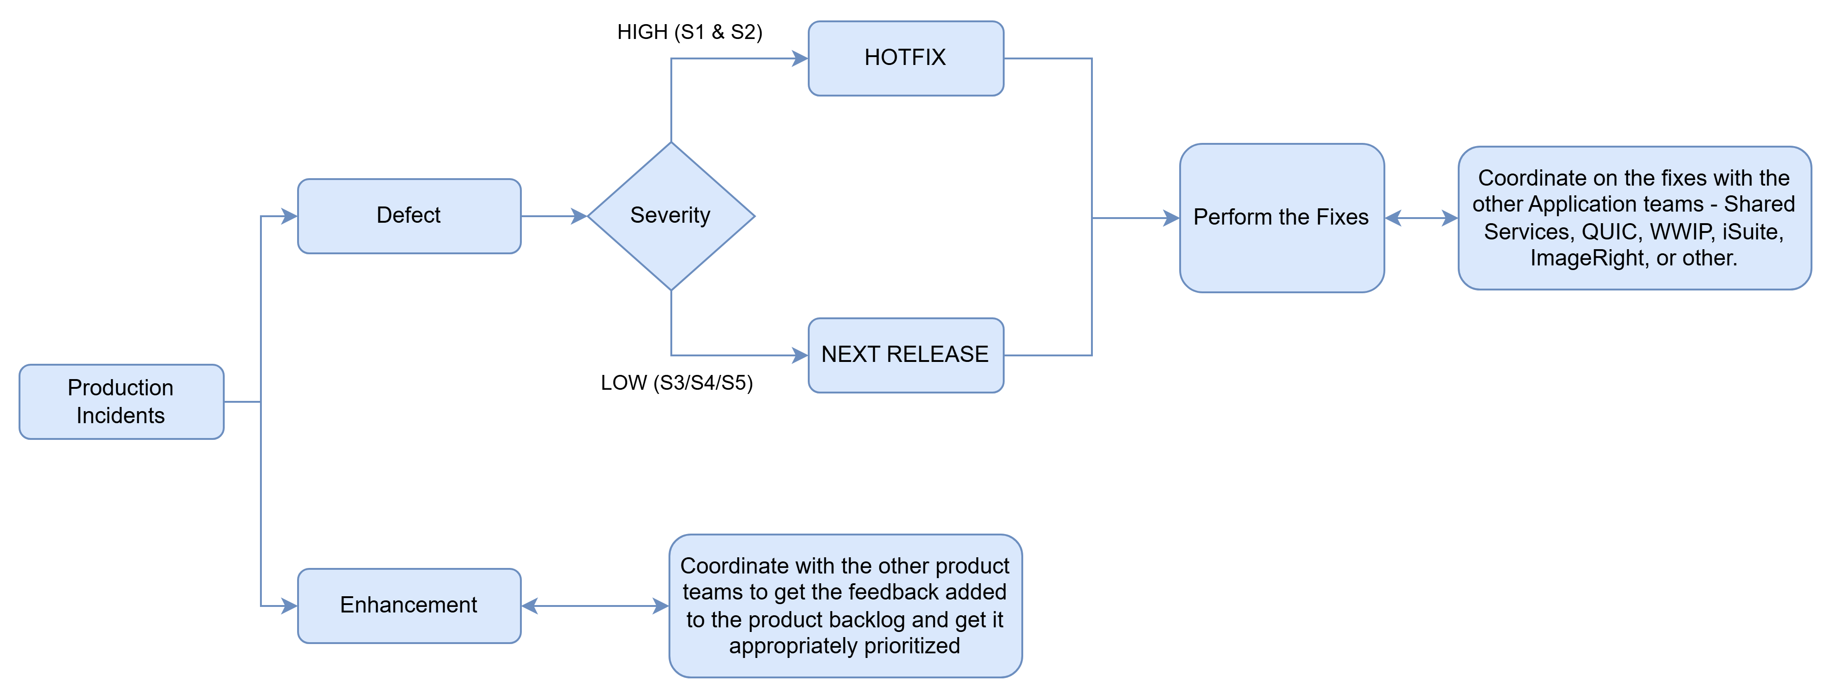

### Scope Of Work

UW Assist Production Stabilization team is responsible for post-release stabilization and production support for only those Lines of Business (LOBs) and applications defined in the ***LOB Supported*** tables.

The team’s scope includes triaging and resolving incidents, coordinating fixes with delivery and dependent system teams, validating end-to-end UW Assist workflows and integrations, managing incident communications, performing root cause analysis, and supporting the transition to Enterprise Support once stability is achieved.

#### LOB Supported

Production Stabilization team supports the lines of business mentioned in the [Link](https://share.connect.aig/:x:/r/teams/GenAI/Shared%20Documents/Underwriting%20Co-Pilot/0%20-%20UW%20Assist%20Files/05-Production%20Stabilization%20Squad/Process%20and%20Standards/PS_LOB%20Supported.xlsx?d=w9d60bfaeb8654349b6b874e1c9644475&csf=1&web=1&e=YzgFI0).

Any support for line of business (LOB) outside the list would require you to follow new LOB onboarding procedure.

#### Application-to-UW Assist Mapping

The below are the [list](https://share.connect.aig/:x:/r/teams/GenAI/Shared%20Documents/Underwriting%20Co-Pilot/0%20-%20UW%20Assist%20Files/05-Production%20Stabilization%20Squad/Process%20and%20Standards/UWA_Integrations.xlsx?d=w460d647dacac40158fbd8c8ddbc5b905&csf=1&web=1&e=9zv2cR) of integrations (upstream & downstream) to the UW Assist application.

#### Out-of-Scope

* Any requests, incidents, or changes that fall outside the LOBs or application mapping documented in the above tables are considered out-of-scope and will be redirected to the appropriate owning teams – inclusion of additional LOB’s or application requires formal review, approval, and documentation updates to clearly establish scope and ownership.
* Fixing Non-production Issue

### Hotfix Release

The diagram illustrates the expedited hotfix release process used to resolve critical production issues with minimal risk and downtime.

Hot Fix Process document - [Link](https://share.connect.aig/:w:/r/teams/GenAI/Shared%20Documents/Underwriting%20Co-Pilot/0%20-%20UW%20Assist%20Files/05-Production%20Stabilization%20Squad/Process%20and%20Standards/01%20-%20Prod%20deployment%20process%20-%20Hotfix.docx?d=w88143e08bd81465390837fbcebce20cf&csf=1&web=1&e=nb8P8T)

Here below is the list of environments for hotfixes environments designated for production stabilization team.

|  |  |
| --- | --- |
| *Development* | *DEV3* |
| *QA* | *QA3* |
| *Production* | *PROD* |

Here is the link to environment access designated for individual team member in the production stabilization team - [Link](https://share.connect.aig/:x:/r/teams/GenAI/Shared%20Documents/Underwriting%20Co-Pilot/0%20-%20UW%20Assist%20Files/05-Production%20Stabilization%20Squad/Process%20and%20Standards/Stabilization%20Playbook/UWA-PS_EnvironmentAccess.xlsx?d=wce73bd7a29484ecda4459f8f64cd150c&csf=1&web=1&e=velMOm)

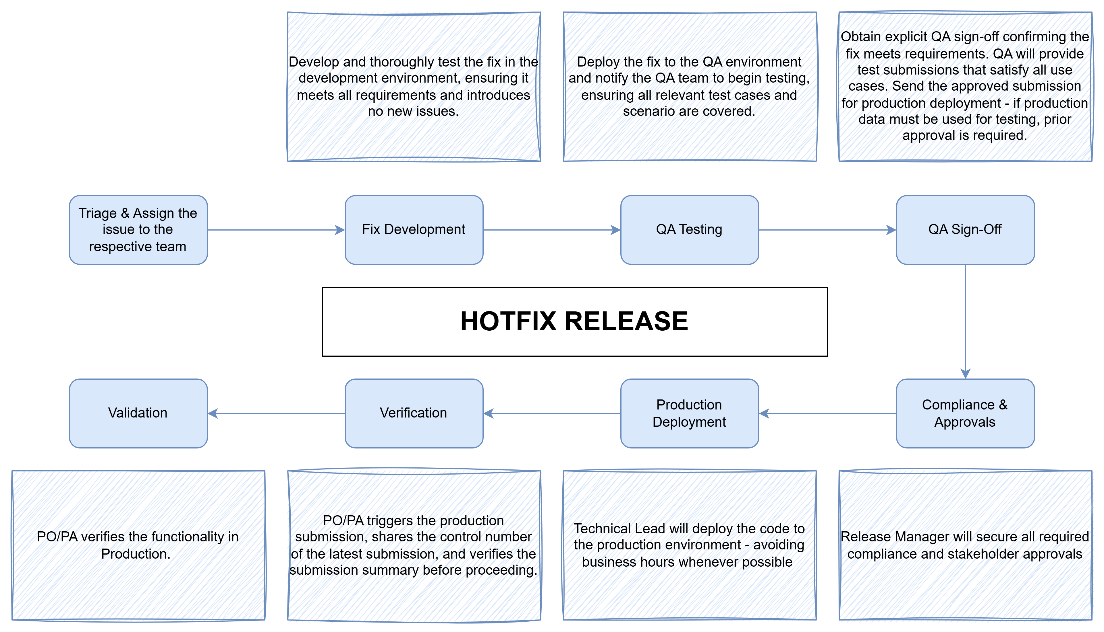

### Regular Release

Regular release follows the established Release Management and Change Management processes, including full planning, approvals, testing, and scheduled deployment.

Release Management SOP [Link](https://share.connect.aig/:b:/r/teams/GenAI/Shared%20Documents/Underwriting%20Co-Pilot/0%20-%20UW%20Assist%20Files/11%20-%20Release%20Management/Documentation/GenAI%20Assist%20Release%20Mgmt%20Playbook.pdf?csf=1&web=1&e=SoEFsi)

### Work Locations & Support Timing

To ensure seamless collaboration and timely support, the table below outlines the work locations and core support hours for the Production Stabilization team.

|  |  |  |
| --- | --- | --- |
| Shore | Location | Timing |
| Onshore Team | USA | 8 AM to 5 PM EST |
| Offshore Team | India | 8 AM to 5 PM IST |

Any tickets or incidents reported post 5 PM EST will be addressed on the subsequent business day, unless they are classified as P1 or P2 critical issues requiring an immediate hotfix.

# 4. Core Processes & SOPs

## 4.1 Incident Management SOP

The purpose of this Incident Management SOP is to establish a standardized, repeatable process for managing service incidents, enabling rapid service restoration while minimizing impact to business operations and customers.

### 1. Detection & Logging

Users of UW Assist can report issues, propose new enhancements, or share suggestions through various channels. Users of UW Assist can easily communicate the challenges they encounter with the service, ask questions about the product, or share ideas for its enhancement. They can do this using any of the options provided below.

1. **Customer Support Form within UW Assist:** Users are encouraged to use the easy-to-use Customer Support Form in UW Assist to report incidents live, at their convenience.

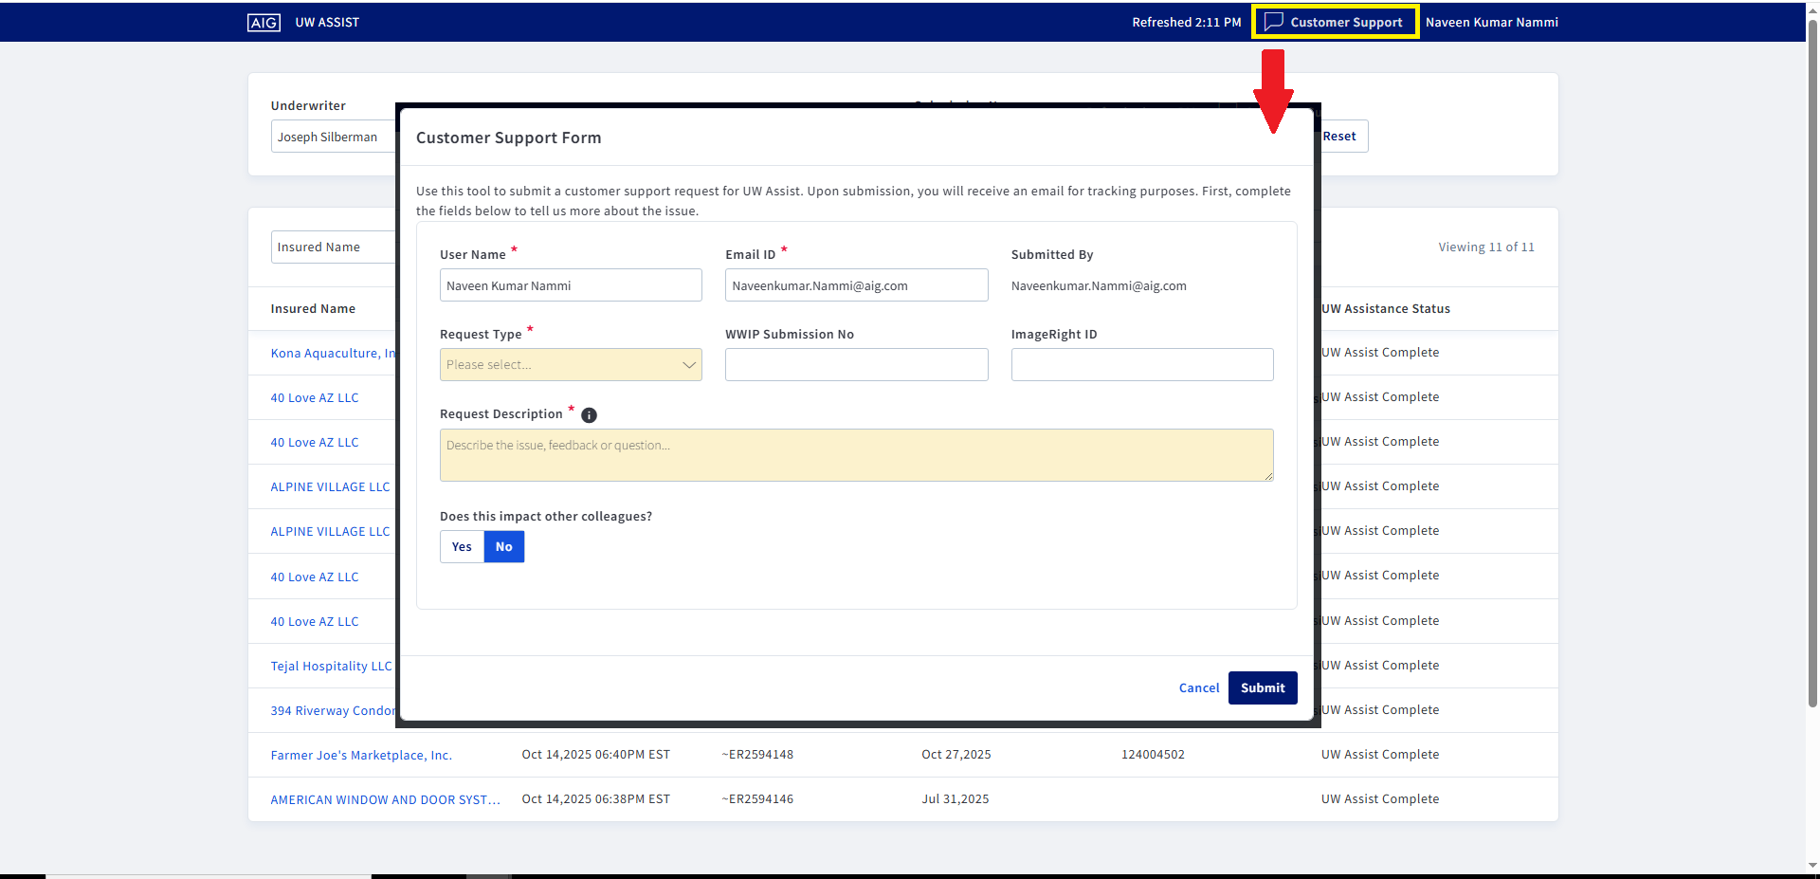

Customer Support Form is integrated with Service Now (SNOW) and would trigger an email to the UW Stabilization Support team as soon as the feedback is submitted.

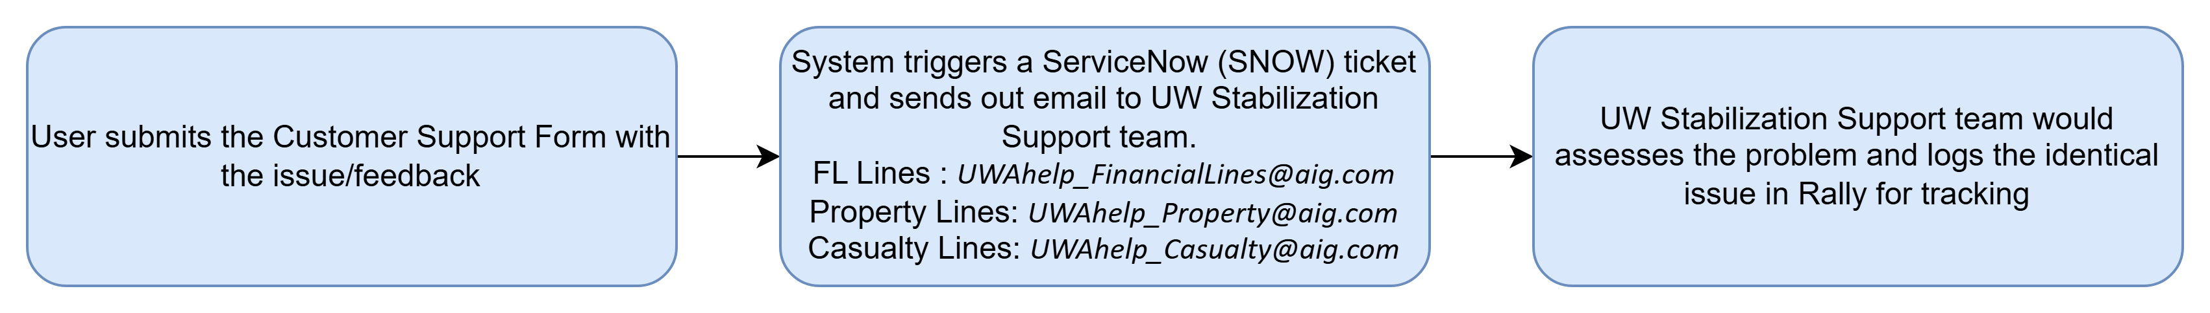

Attached here is an example email sent out to the UW Stabilization Support team.



1. **UW Assist Community Hub:** UW Assist Community Hub is a one-stop-shop MS Teams channel for all things UW Assist for users. Users are encouraged to share questions or comments on this channel for support.

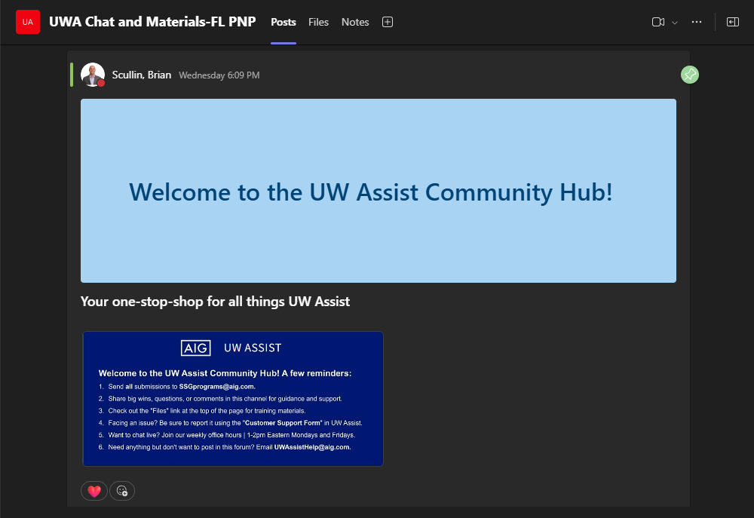

1. **UW Assist Office Hours:** Office Hours is a weekly recurring meeting with Underwriters to raise questions, comments and ideas to UW Assist team members.

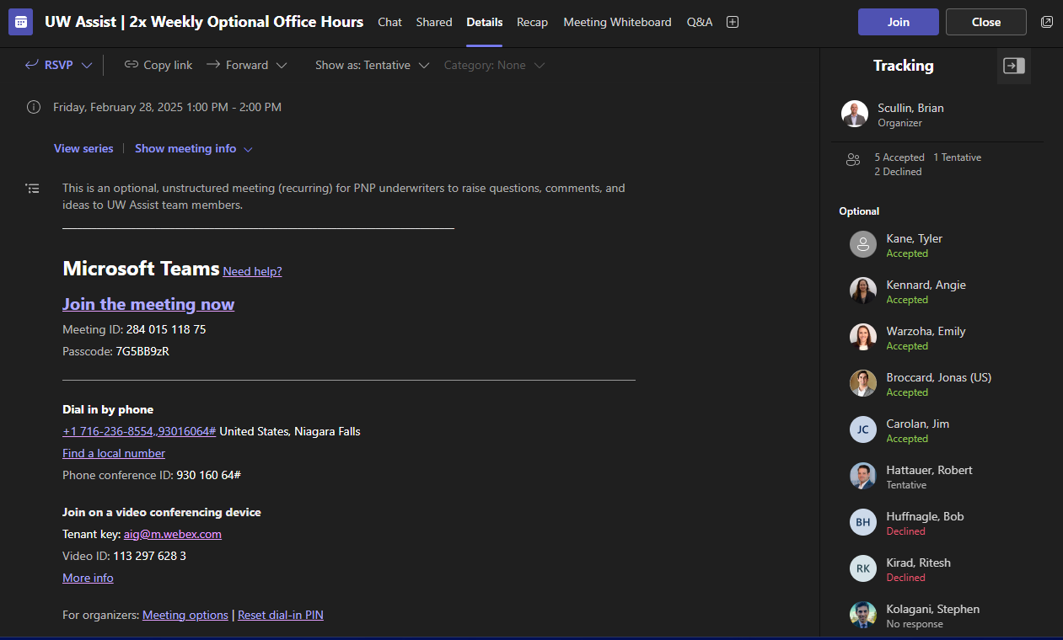

1. **Training / Onboarding:** During local office training and onboarding of new Underwriters to UW Assist, users are presented with opportunities to ask questions and discuss with the UW Assist Product Team.

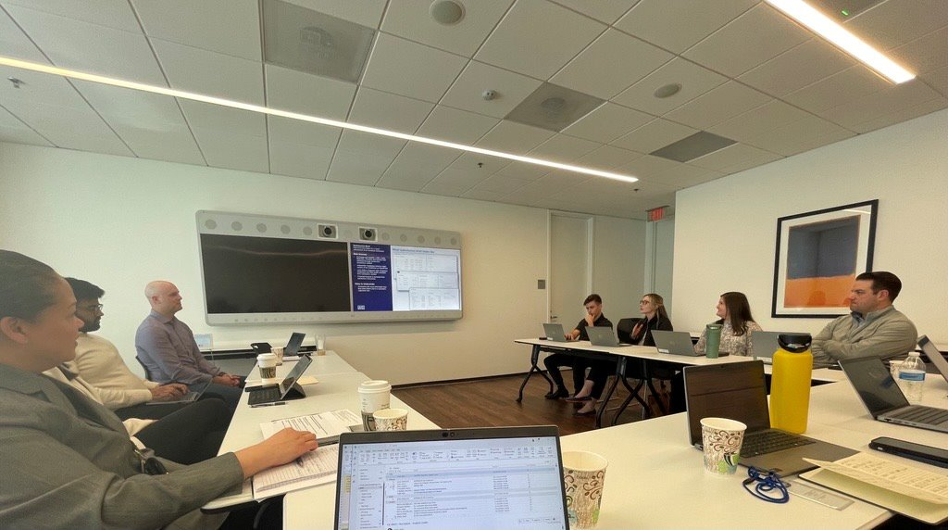

1. **UW Council Meetings:** Underwriters are engaged weekly to provide input on the product and design decisions related to planned features. These are great opportunities for Underwriters to provide feedback and report defects in Production.
2. **In-Person / Email:** Underwriters are encouraged to raise issues with the UW Assist Product team in person or through the emails below (according to the LOB).

|  |  |
| --- | --- |
| *Financial Lines* | [*UWAhelp_FinancialLines@aig.com*](mailto:UWAhelp_FinancialLines@aig.com) |
| *Property Lines* | [*UWAhelp_Property@aig.com*](mailto:UWAhelp_Property@aig.com) |
| *Casualty Lines* | [*UWAhelp_Casualty@aig.com*](mailto:UWAhelp_Casualty@aig.com) |

User-reported defects through the channels mentioned above are scrutinized by the Product team and the Production Stabilization Squad. These issues are documented in the Rally Board ([Link](https://rally1.rallydev.com/)), which is the authoritative source for all open and closed defects in Production. The "Production Stabilization – Daily Standup" call is utilized to monitor these defects, promoting effective ownership and resolution.

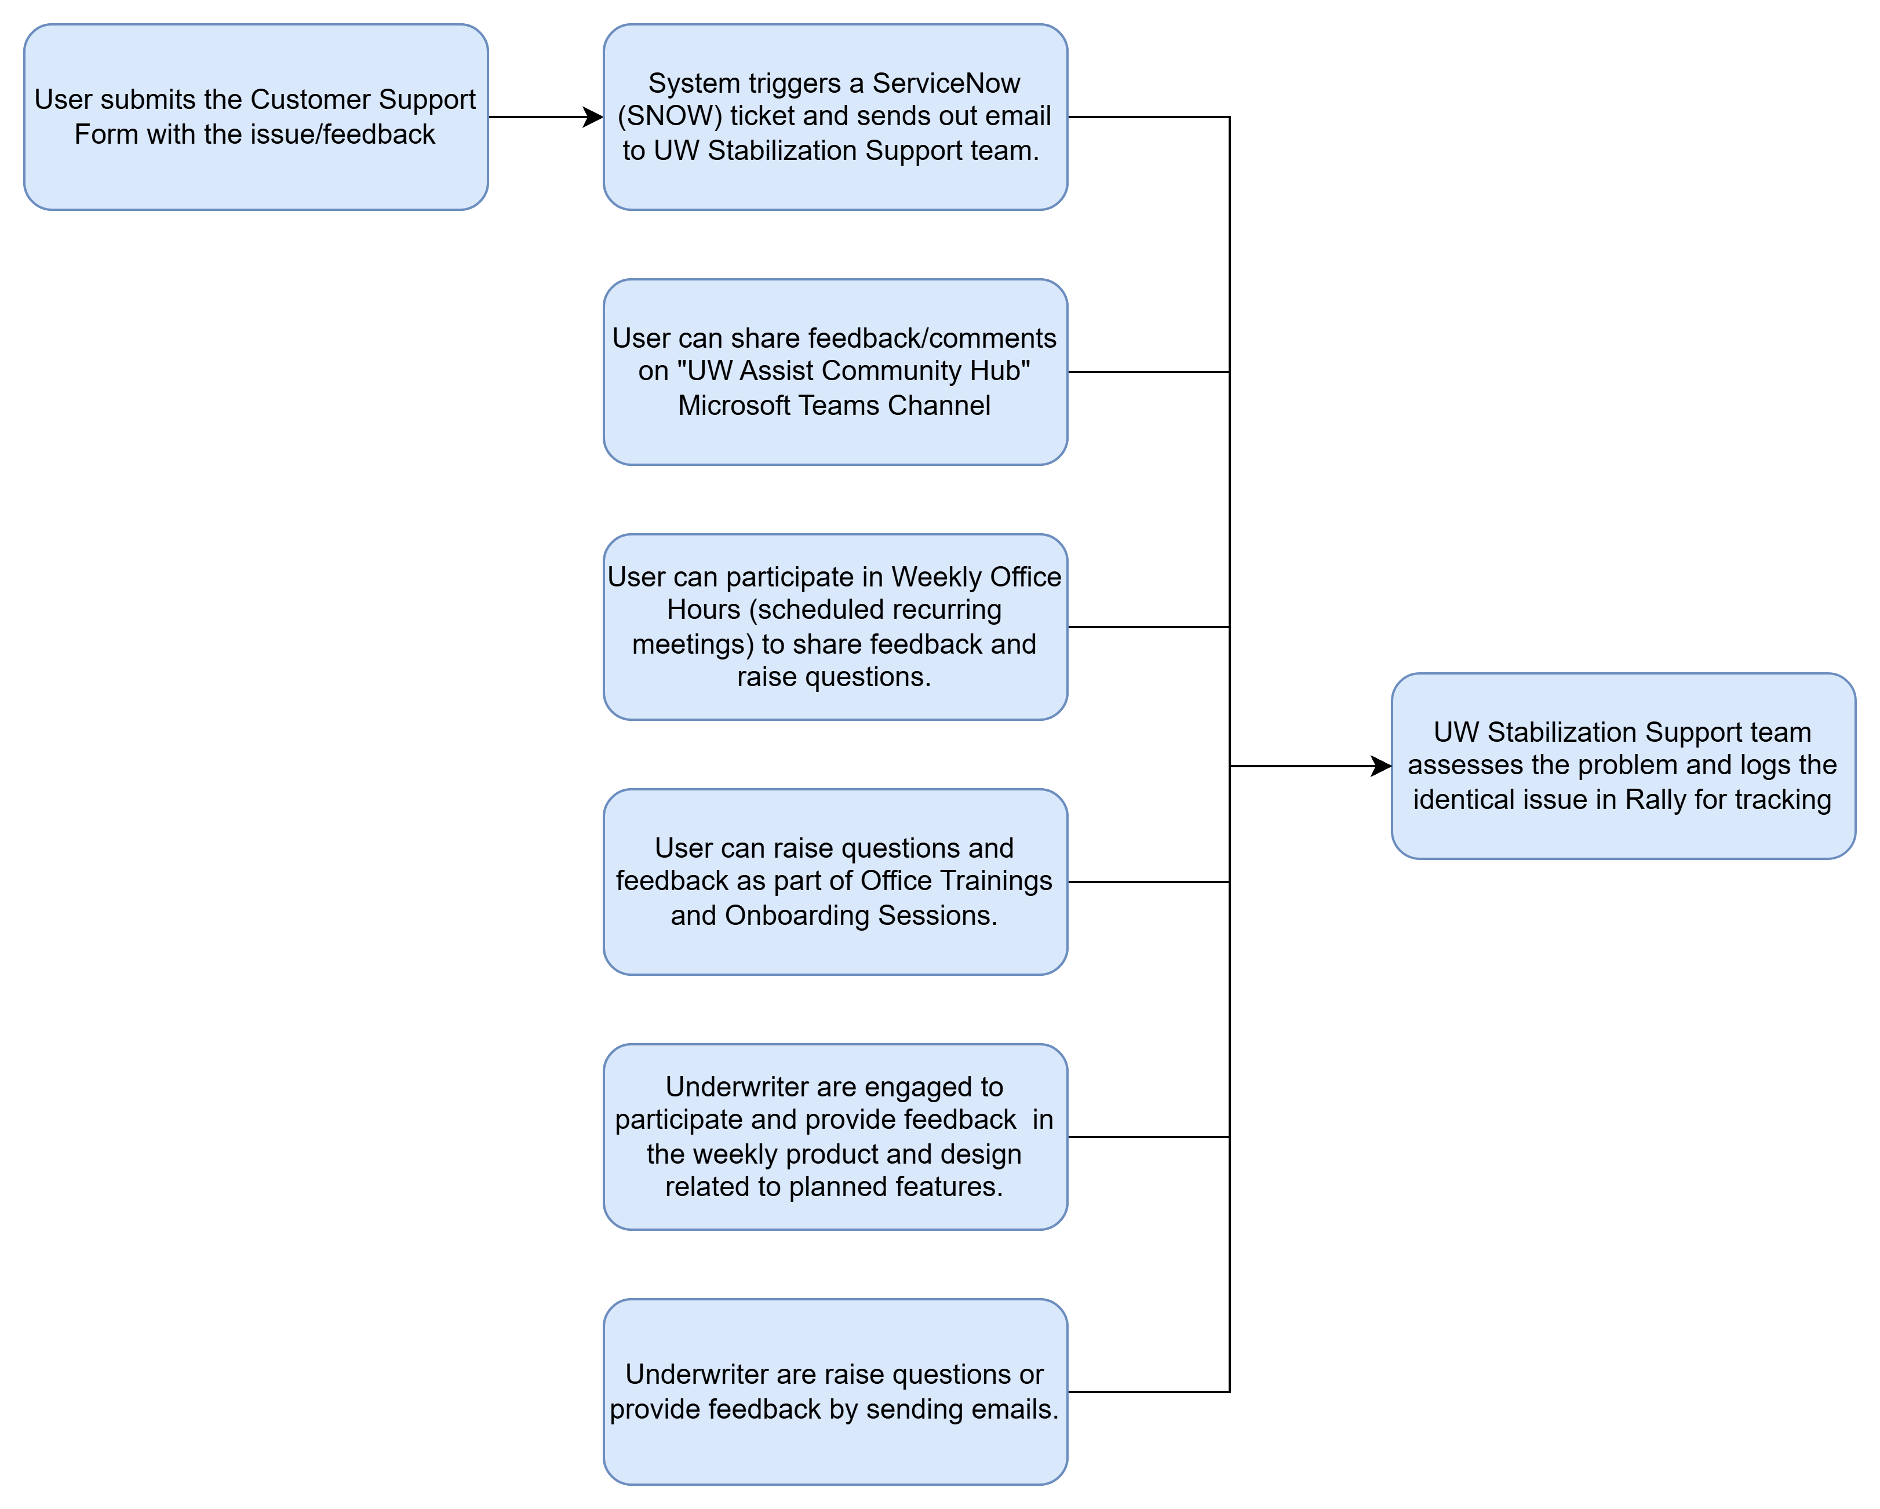

### 2. Triage & Prioritization

The triage process is employed to swiftly evaluate and prioritize incidents or issues, assessing their impact, pinpointing the causes, and formulating preventive and corrective measures. This procedure takes place during daily cross-functional meetings with Business SMEs and the Production Stabilization Squad.

Upon receiving an alert or incident report, the support team:

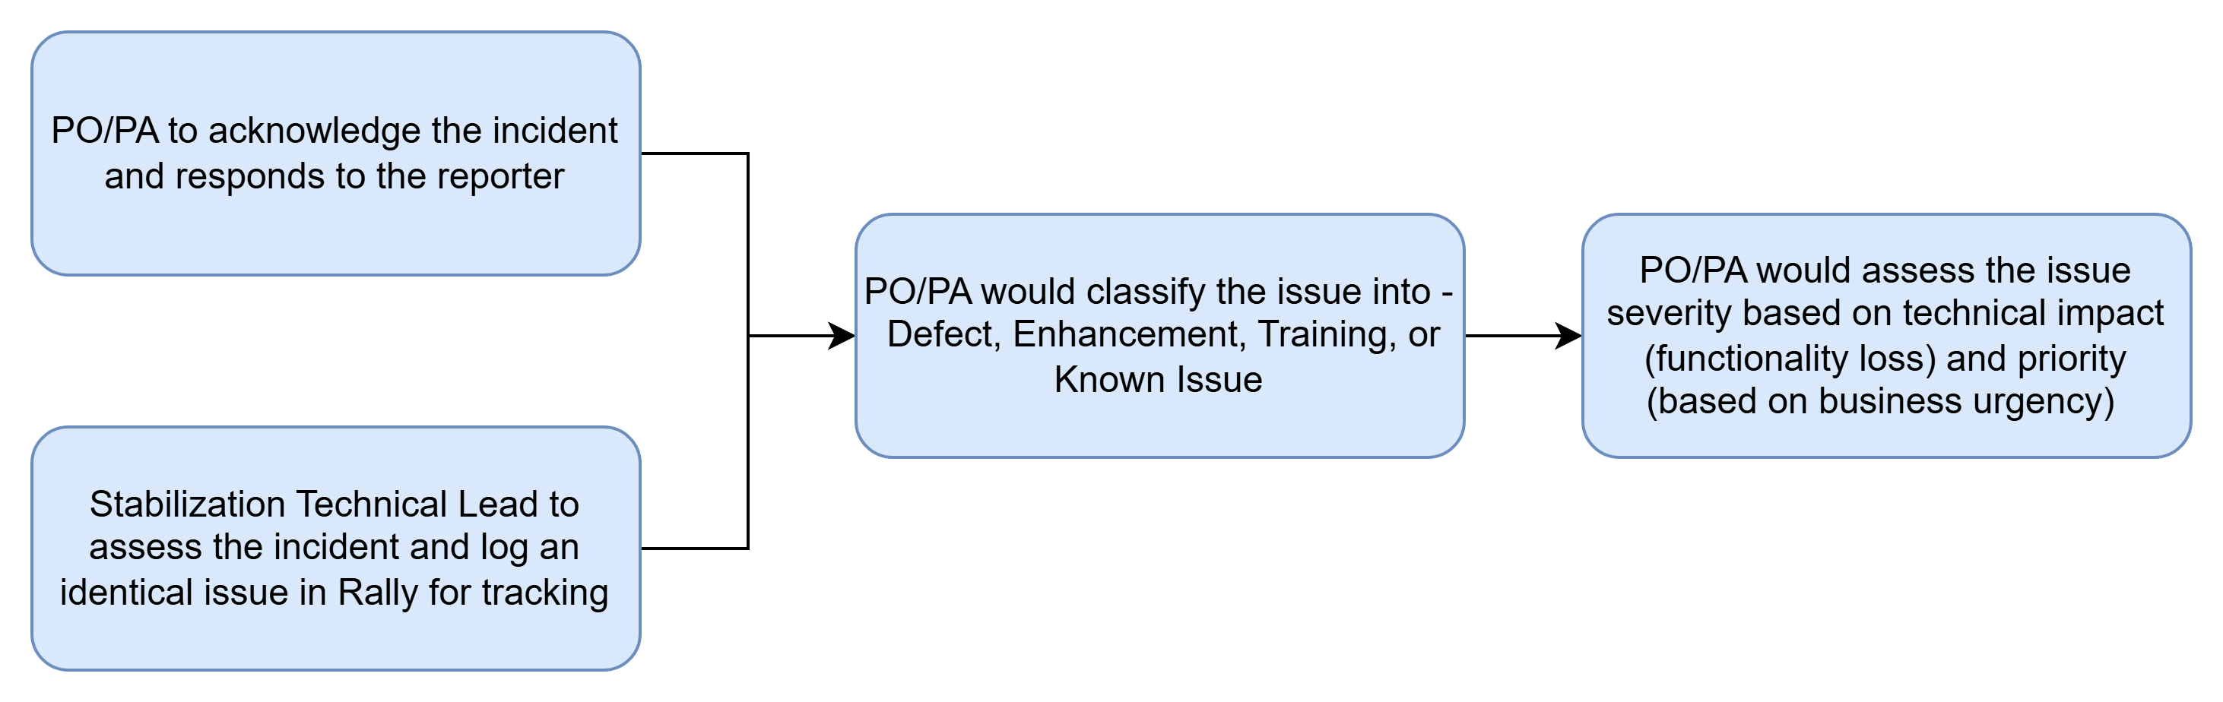

The defects are assigned with severity and priority using the guidelines below.

**Severity** – Severity is assigned to an issue in consultation with Business SME and communicated to the user.

|  |  |  |
| --- | --- | --- |
| Severity | Severity Definition | Example |
| 1 – Urgent | System is down or unusable, and no reasonable workaround exists. | [DE207305](https://rally1.rallydev.com/#/810009666767ud/teamboard?detail=%2Fdefect%2F816808832743%2Fdetails&keywords=DE207305) - [Prod Issue] Submissions stuck in classification status since yesterday 12-19 at 3pm |
| 2 – High | A significant feature is broken, but a difficult workaround may exist. | [DE227554](https://rally1.rallydev.com/#/810009666767ud/myrally?detail=%2Fdefect%2F829251294897%2Fdetails&keywords=DE227554) - [Prod Issue] Notification sent to Broker instead of UW. |
| 3 – Medium | A feature does not work as expected, impacting user workflow, but does not block them. | [DE227586](https://rally1.rallydev.com/#/810009666767ud/myrally?detail=%2Fdefect%2F829275934269%2Fdetails&keywords=DE227586) - [Prod Issue] Internal search is failing for submissions with Industry Group 12 |
| 4 – Low | Minimal impact on user experience. Mostly a nuisance that does not require a workaround. | [DE219034](https://rally1.rallydev.com/#/810009666767ud/myrally?detail=%2Fdefect%2F823867999081%2Fdetails&keywords=DE219034) - [Prod Issue] Submissions is not getting removed automatically after 90 days or QUIC status gets updated to ‘Lost’, ‘Declined’, ‘Bound’, ‘Void |
| 5 – Cosmetic | No functional impact. Aesthetic issues only. | [DE218850](https://rally1.rallydev.com/#/810009666767ud/myrally?detail=%2Fdefect%2F823709938889%2Fdetails&keywords=DE218850) - [Prod Issue] Question mark showing up instead of "-" in the workup email. |

**Priority** – Priority guides the order in which an issue is resolved by the team.

|  |  |  |
| --- | --- | --- |
| Priority | Priority Definition | Action |
| 1 – Critical | **System down** -Core functionality is unavailable, major data loss, or security breach. | Immediate triage and around-the-clock resolution efforts required. |
| 2 – High | **Severe Impairment** - System is running, but key features are broken with no workarounds –  impairs usage unless fix is delivered | Fix required ASAP in the next hotfix. |
| 3 – Medium | **Degraded Functionality** - Feature issue with a workaround available. | Added to the product backlog and fix planned for the next upcoming regular release. |
| 4 – Low | **Minor Issue** - Minor bug, UI annoyance, or cosmetic error. | Added to the product backlog and planned for future development as resources allow. |
| 5 – Low | **Suggestion** - Not a functional defect, but a request for future improvement, or a "nice-to-have" change. | Added to the product backlog and planned for future development as resources allow. |

### **3. SLA for Resolution & Escalation**

If the initial assignee cannot resolve the issue within the designated time frame, the incident must be escalated using the framework below.

|  |  |  |  |  |
| --- | --- | --- | --- | --- |
| Severity | Production Support SLA | Team initial analysis and response | Escalation Path | Team SLA for Resolution |
| 1 – Urgent | Acknowledge in 15 mins - 1 Hr.  Resolve in < 1 day | Within 30 mins | Escalate to Tech Lead in 1 hour -> Escalate to Engineering Manager in 1.5 hours -> Escalate to Leadership in 2 hours. | Fix within 8 hours. |
| 2 – High | Acknowledge in 15 mins - 1 Hr.  Resolve in < 2 day | Within 2 Hrs. | Escalate to Tech Lead in 2.5 hours -> Escalate to Engineering Manager/Leader/Service Owner in 4 hours. | Fix within 1 day. |
| 3 – Medium | Acknowledge in 15 mins - 1 Hr.  Mutually agreed upon, target milestone (release) | Within 1 day | Escalate to Tech Lead in 1 day -> Escalate to Engineering Manager/Leader/Service Owner in 2 days. | Fix in next sprint or release. |
| 4 – Low | Acknowledge in 15 mins - 1 Hr.  Mutually agreed upon, target milestone (release) | Within 2 days | Escalate to Tech Lead in 3 days -> Escalate to Engineering Manager/Leader/Service Owner in 4 days. | Fix in next sprint or release. |
| 5 – Cosmetic | Acknowledge in 15 mins - 1 Hr.  Mutually agreed upon, target milestone (release) | Within 3 days | Escalate only during grooming/planning. | Fix in next sprint or release. |

### **4. Communication Protocols**

The communication protocol for incident management ensures that technical responders, business leaders, and customers remain aligned through consistent, transparent updates.

Below table defines the priority-based service targets and communication expectations to support effective incident management, stakeholder transparency, and operational governance.

|  |  |  |  |  |  |  |
| --- | --- | --- | --- | --- | --- | --- |
| Priority | Priority Definition | Initial Response to User/s | Analysis Target | Resolution Target | Communication | Audience |
| 1 – Critical | System is unusable until fixed. Immediate triage and resolution is needed. | 15 mins – 1 Hr. | Within 3 hours. | Within a business day. | Every 1 hour | GenAI-Assist Prod Support, Program and Product Leadership, UWA Users |
| 2 – High | Must be fixed ASAP – impairs usage unless fix is delivered | 15 mins – 1 Hr. | 1 business day | 1-2 Business Day | Every 2 hours | GenAI-Assist Prod Support, Program and Product Leadership, UWA Users |
| 3 – Medium | Resolved during regular cycles – can wait for next build | 15 mins – 1 Hr. | 2-3 business days | Mutually agreed upon – target milestone (release) | Weekly | GenAI-Assist Prod Support, Program and Product Leadership |
| 4 – Low | Irritant, Fix after critical defect | 15 mins – 1 Hr. | 3-5 business days | Mutually agreed upon – target milestone (release) | Weekly | GenAI-Assist Prod Support, Program and Product Leadership |
| 5 – Low | Irritant, Fix after critical defect | 15 mins – 1 Hr. | Based on team’s capacity | Mutually agreed upon – target milestone (release) | Weekly | GenAI-Assist Prod Support, Program and Product Leadership |

**RACI Matrix –** It is used to define and document roles and responsibilities for tasks, milestones, or decisions in the UWA Stabilization Support team.

|  |  |  |  |  |
| --- | --- | --- | --- | --- |
| Task | Prod stabilization PO/PA | Prod stabilization Tech Lead/Engineer | Prod stabilization Development Team | Prod stabilization DQ Team |
| Monitor & Detect Incident | I | R | C | I |
| Classify the incidents into Defects/Enhancements/Training/Known Issues | A | C | C | C |
| Log Incidents | A | R | C | I |
| Assigning Severity & Priority | A/R | C | C | C |
| Communicate End Users/Stakeholders | A/R | C | C | C |
| Perform Initial Triage | C | A | R | C |
| Determine Ownership (Component) – only items that are truly defects | I | A | C | C |
| Conduct RCA – only for items that are truly defects | C | C | R | R |
| Fix/Implement Resolution – only for items that are defects in Prod stabilization scope | I | C | A/R | I |
| Perform Testing of Fix | C | C | C | A/R |
| Deploy Fix to the Production | C | A | R | C |
| Update the Knowledge Base/Documentation for Workaround | A/R | A/R | C | C |
| Close the defect in all the systems (Rally & SNOW) | I | A | C | C |

|  |  |  |  |
| --- | --- | --- | --- |
| ***R (Responsible)*** | ***A (Accountable)*** | ***C (Consulted)*** | ***I (Informed)*** |
| *Individual(s) who do the work to complete the task or deliverable. Responsibility can be shared among multiple people.* | *Individual who is ultimately answerable for the outcome of the task or activity and has the authority to approve or reject the work.* | *Subject Matter Expert who are asked to provide input, advice, or guidance before a decision or action is taken.* | *Individuals who need to be kept up to date on progress or decisions, typically after the task or decision is completed.* |

### **5. Closure & Documentation**

An incident is considered closed only after stability is restored, the resolution is validated by the business, and all supporting records are completed to enable transparency and learning.

Not everything require a fix and include Recurrence

|  |  |  |
| --- | --- | --- |
| *Activity* | *Responsibility* | *Task Description* |
| Verification and Validation | DQ | *Perform health checks and regression testing to confirm if the fix is stable.* |
| Technical Lead | *Obtain formal sign-off from the business stakeholder or PO to confirm code push into production.* |
| Ticket Categorization and Cleanup | Developer | *Update the incident record with the actual cause rather than the symptoms reported at intake.* |
| PA/PO | *Confirm if the initial severity level was the actual accurate or needs adjustment based on the actual impact discovered during resolution.* |
| Developer | *Link the incidents to any related problem records or changes requests in Service Now or Rally.* |
| Knowledge Management | Developer | *If the resolution involves a unique fix, convert the technical notes into a searchable knowledge article for Tier 1 support.* |
| Technical Lead | *Document specific “Corrective Actions” with assigned owners and due dates to prevent recurrence.* |
| Technical Lead | *Standardize the incident timelines, capturing the exact data points for KPI and SLA reporting.* |
| Formal Closure | Technical Lead | *Mark the incident as “Closed” in both Rally and Service Now (SNOW), to stop the SLA clock.* |
| PA/PO | *Send a final “Incident resolution” communication to all the stakeholders, including a high-level summary of the fix and next steps for the root cause investigation.* |

### 6. Post-Incident Review (RCA)

Every defect is investigated beyond simple post-mortem by using structured methodologies to determine the actual root cause.

Some of the common root cause techniques include – Ishikawa Diagram, 5 WHYs, Logic Tree Analysis, Change Analysis (Before vs After), Lineage Tracking, Pareto Analysis (80/20 rule to identify the vital few), FEMA (Failure Mode and Effects Analysis).

1. **Failure Model Effects Analysis:**

It is a framework followed during defect resolution with the goal of “error proofing” the UW Assist product, the team follows the following framework to review the preventive and corrective actions formulated.

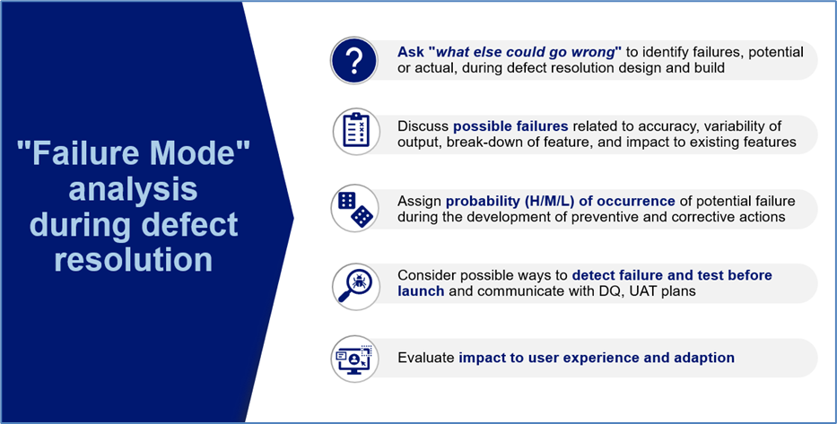

1. **Preventive and Corrective Actions:**

It is a framework followed with the goal of “error proofing” the UW Assist product. Every defect is assigned to preventive and corrective action. This is a key input into the product delivery lifecycle as feedback from production usage.

|  |  |
| --- | --- |
| Preventive Action | Corrective Action |
| Preventive action is aimed at minimizing the probability of recurrence in part or whole. It is used as input into design by the Product Owners. | Corrective action is aimed to remediate the current defect and resolve with the user experience in mind. It is used along with root-cause analysis as an input into Product Feature design by the Product Owners. |

## 4.2 New LOB Onboarding SOP

**Purpose**: The SOP defines the standardized processes for onboarding a new line of business (LOB) into the Underwriting Assist application, ensuring controlled stabilization, seamless integration across upstream and downstream systems, and a smooth transition to Enterprise Support team once operational stability is achieved.

LOB Onboarding Workflow –

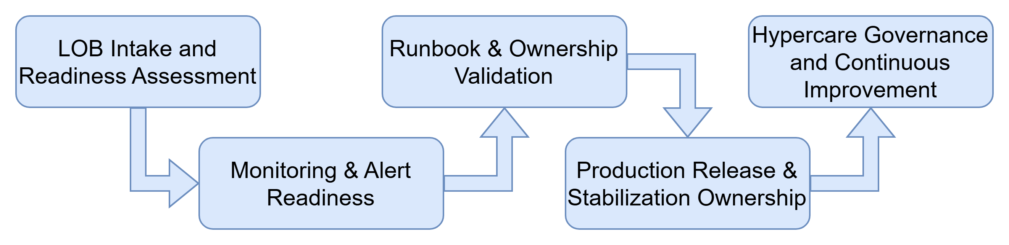

### 1. LOB Intake & Readiness Assessment

* Conduct LOB onboard kick-off with all stakeholders.
* Capture functional and technical overview –

|  |  |
| --- | --- |
| Functional Overview | Technical Overview |
| * Review LOB functional scope and critical business flows and underwriting workflows. * Understand LOB specific rules, validations, and decision points. * Define clear Service Level Objectives (SLO) and Service Level Agreements (SLA) for different business flows, adjust to understand resource scaling needs during peak times. | * Review integration touchpoints (upstream/downstream). * Capture APIs, batch jobs, event streams, and schedulers. * Understand the architecture diagram * Understand data contracts, error handling, and dependencies. |

* Define KEDB “Known Error Db”, document with common workarounds
* Confirm stabilization of duration and metrics (incident volume below threshold).
* Deliverables –
  + LOB Functional Overview
  + Technical Integrations Inventory
  + Risk and Dependency Register, KEDB

### 2. Monitoring & Alert Readiness

* Define LOB-specific monitoring requirements.
  + Transaction Success/Failure Rate.
  + Integrations latency and error thresholds.
  + Infrastructure and application of health metrics.
* Ensure monitoring, logging, and alerting are enabled for new LOB flows.
  + Logs and alerts are enabled, they are available for troubleshooting
  + Alerts are actionable, severity-based, and routed correctly
  + Alert scenarios are tested prior to release and update them as needed
* Validate dashboards are available for hypercare monitoring.
* Deliverables –
  + Monitoring & Alert Configuration Checklist.
  + Alert Runbooks and Escalation Points.
  + Alert Validation Evidence.

-

### 3. Runbook & Ownership Validation

* Review and validate operational runbooks, including –
  + Common failure scenarios and remediation steps
  + Integration restarts and recovery procedures.
  + Known defects and workarounds documented in KEDB
* Confirm –
  + Clear ownership for incidents, defects, and alerts.
  + On-call and escalation models.
  + Collaboration path b/w Product, Delivery, and Stabilization teams.
* Ensure runbooks are approved and accessible.
* Deliverables –
  + Approved Runbooks
  + Ownership and Escalation Matrix (RACI)
  + Support Contact Directory.

### 4. Production Release & Stabilization Ownership

* Upon production deployment –
  + Production Stabilization team assumes Primary Ownership.
  + Hypercare monitoring begins using defined dashboards and alerts.
* Coordinate incident triage and defect resolution.
* Communicate status and risks to stakeholders

### 5. Hypercare Governance & Continuous Improvement

* Hypercare continues until –
  + Incident volumes stabilize within agreed thresholds.
  + No unresolved S1 & S2 issues remain.
  + Monitoring noise is reduced and turned.
  + Runbooks are validated through live incidents
  + Enterprise Support confirms readiness.
* Conduct post-hyper care retrospective.
* Update intake templates, monitoring standards, onboarding checklists, and runbooks.
* Document lessons learned for future LOB onboarding.

### 6. Focus on Reliability/Performance

* Validated operational procedures that reduced MTTR during a live event.
* Tested and actionable guide, proven during an active incident.
* Runbook audited and confirmed accurately by real-world application.

---------------------------------------------------------------------

TBD

Option 2 on New LOB onboarding will enhance as per the below standard format and include the above details to fit into this standard format.

New LOB Onboarding Phases in Production Support as below

1. **Preparation (Pre-boarding):** Define the scope, identify key stakeholders, and gather initial documentation.
2. **Knowledge Transfer (KT):** Conduct KT sessions, document application architecture, and create troubleshooting guides.
3. **Access & Tooling:** Set up necessary tool access (e.g., Rally, ServiceNow), environment access (e.g., Citrix/VPN, servers), and documentation access.
4. **Shadowing/Reverse Shadowing:** The new LOB team shadows existing support staff, then performs tasks while being monitored.
5. **Go-Live & Support:** Full ownership transition to the new LOB, with ongoing monitoring.

------------------------------------------------------------------

## 4.3 Knowledge Management SOP

The purpose of knowledge management is to ensure critical production issue lessons learned are systematically captured, maintained, and shared – to support faster incident resolution, reduce dependency on individuals, improve onboarding efficiency, and drive continuous service stability.

**Process Steps:**

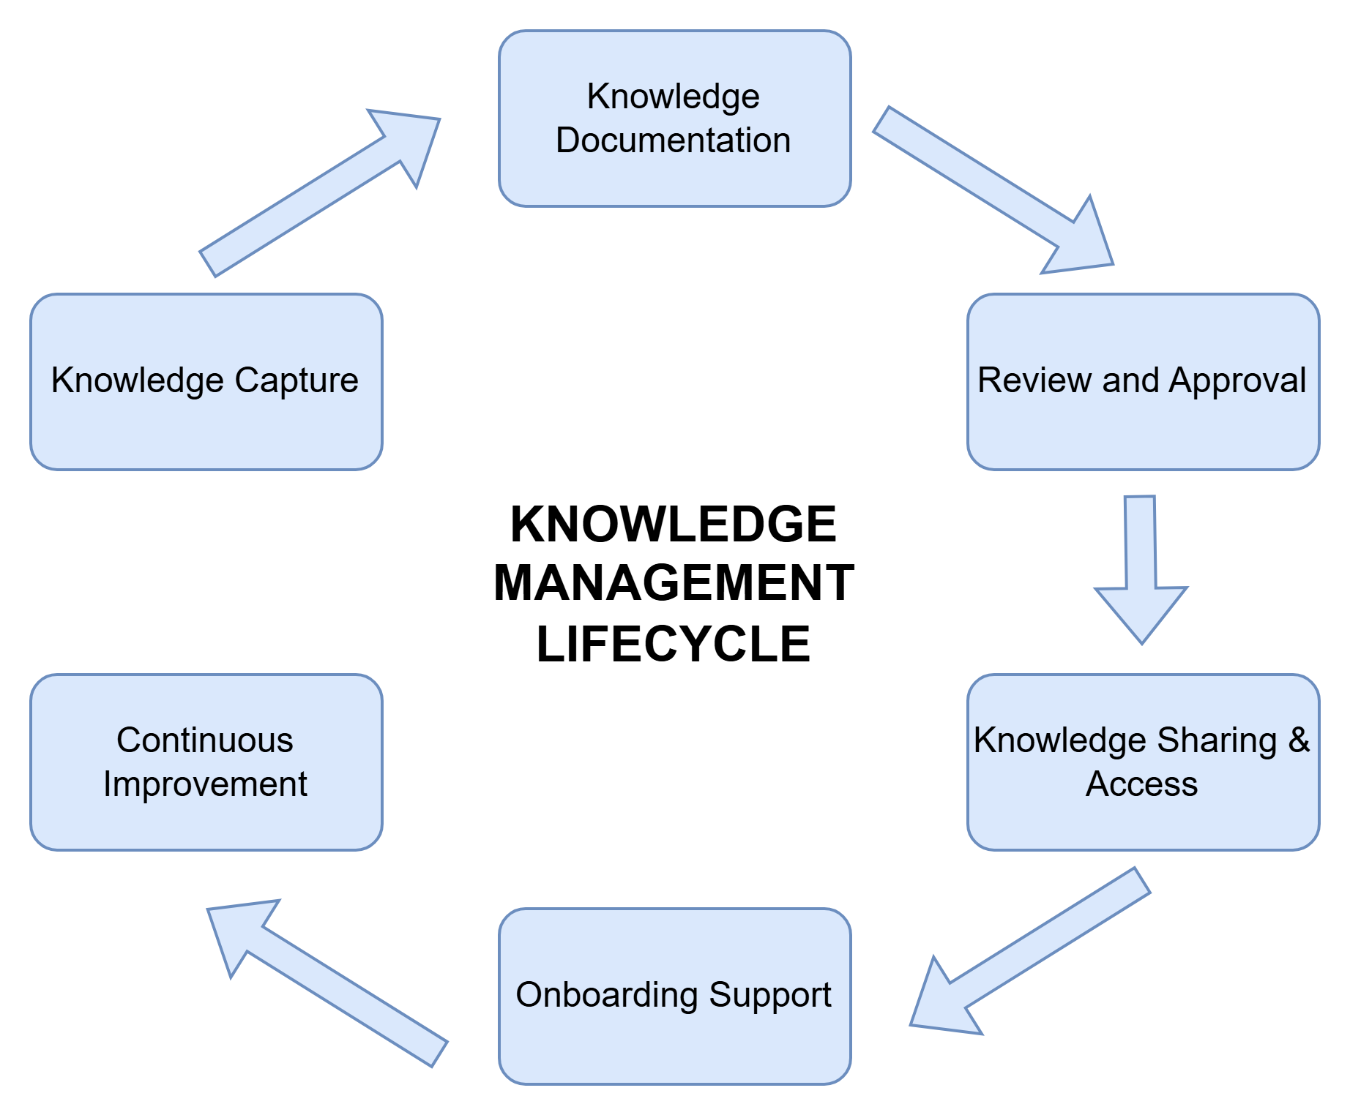

### 1. Knowledge Capture

|  |  |
| --- | --- |
| What to Capture | When to Capture |
| * LOB-specific workflows, integrations, and expected scenarios. * Business Rules and System dependencies – UW rules, decision logic, upstream/downstream dependencies. * Known Errors and Workarounds. * Environment Specific Configurations, Assumptions & Dependencies. * Deployment, Rollbacks, and Recovery steps. * Runbooks and Operating procedures. * Incident RCA themes and lessons learned. | * Post Major Incidents (P1/P2) * After repeated incidents. * After release or production changes. * During shadowing and handover sessions. |

### 2. Knowledge Documentation

Here is the [link](https://share.connect.aig/teams/GenAI/Shared%20Documents/Forms/AllItems.aspx?id=%2Fteams%2FGenAI%2FShared%20Documents%2FUnderwriting%20Co%2DPilot%2F0%20%2D%20UW%20Assist%20Files%2F05%2DProduction%20Stabilization%20Squad%2FKT%20Overview%20Recordings&viewid=3c3accc2%2D5ee1%2D46e5%2Daae4%2D12750da41c13&sharingv2=true&fromShare=true&at=9&CID=c7a9b590%2D26f3%2D444c%2Daf10%2D920000f9cc0e&FolderCTID=0x0120002FC3007F1BFF3A41B89E44C14E4E105E) to “UWA Stabilization” team’s knowledge repository.

Standardized templates for –

* Runbooks & SOPs
* LOB Application Appreciation Documentation
* RCA summaries, preventive and corrective actions
* Known Error Articles
* FAQ and How-To-Guides

### 3. Review & Approval

To ensure accuracy and relevance, all knowledge contents or articles should be reviewed before publication.

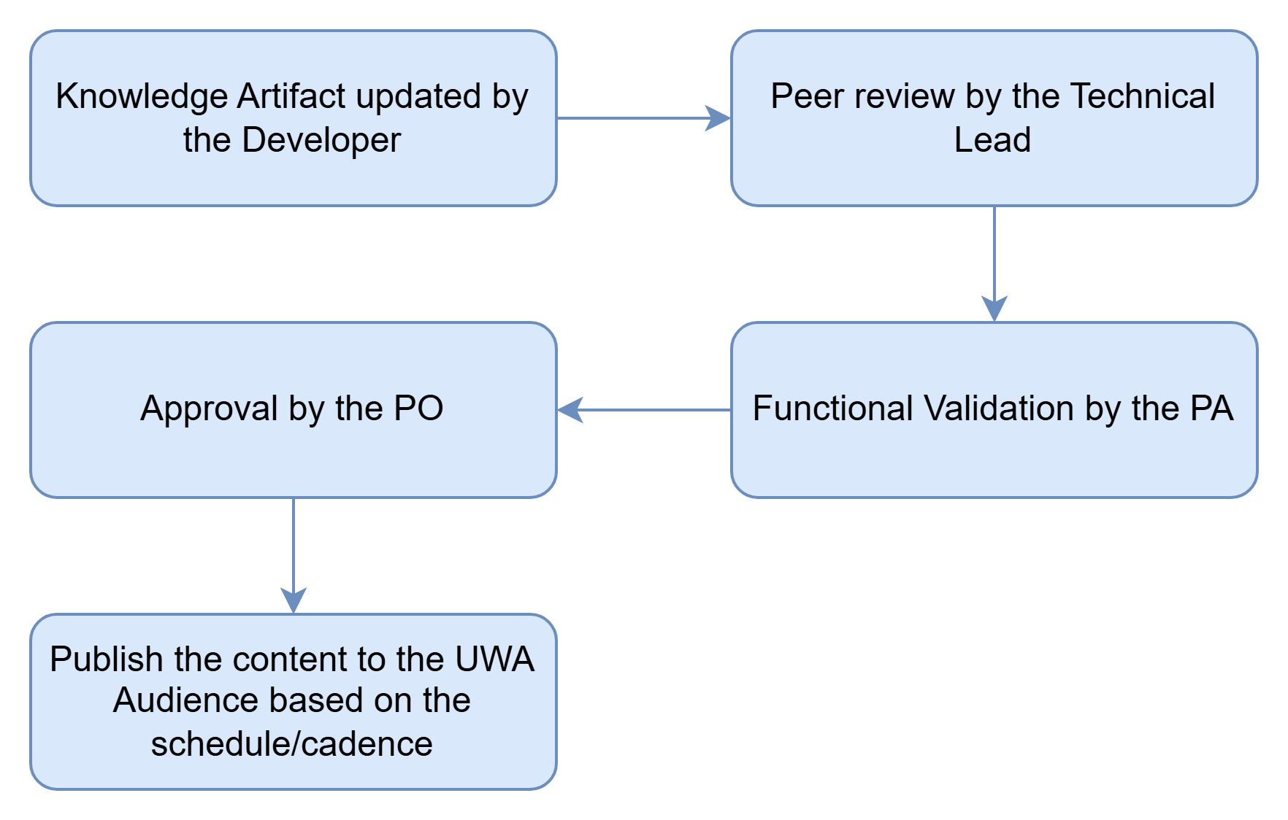

### 4. Knowledge Sharing

Knowledge artifacts ought to be shared promptly and actively, with the ultimate aim of reducing recurring incidents and accelerating Mean Time to Recovery (MTTR).

The revised knowledge document is to be disseminated to the relevant product teams and underwriters on a quarterly basis.

### 5. Onboarding Support

Here is the [link](https://share.connect.aig/:w:/r/teams/GenAI/_layouts/15/Doc.aspx?sourcedoc=%7BB6FCEE8A-2BF9-4F63-ABBA-8A40D2E94251%7D&file=UW%20Assist%20User%20Onboarding%20Process.docx&action=default&mobileredirect=true) to the “UW User Onboarding” documentation.

* Mandatory knowledge walkthroughs for new team members and new LOB onboarding.
* Knowledge validation as part of LOB Go-Live readiness.
* Periodic refresher sessions and release-based updates.

### 6. Continuous Improvement

Knowledge artifacts are living assets that must evolve alongside the system to enhance maturity and ensure resilience.

**Improvement Triggers –**

* Platform or underwriting changes
* Observability and Monitoring gaps
* Process inefficiencies identified during support
* Incident trends and repeat issues
* RCA findings
* SLA breaches

**Actions –**

* Update or retire outdated section of the knowledge document.
* Enhance runbooks based on real incidents and lessons learned.
* Automate manual steps where feasible.

### 7. Knowledge Management – SLA & Metrics

|  |  |  |
| --- | --- | --- |
| Metric | Explanation | Formula |
| Knowledge Utilization Rate | % of incidents resolved using documented knowledge. | [Number of incidents resolved using knowledge document / Total Incidents] * 100 |
| Repeat Incident reduction Rate | Reduction in repeated incidents. | [(Previous Period repeat Incidents – Current Period repeat Incidents) / Previous Period repeat Incident] * 100 |
| Improvement in MTTR (Mean Time to Resolve) | Measures reduction in resolution time due to availability of knowledge documents. | [(Baseline MTTR – Current MTTR) / Baseline MTTR] * 100 |

# 5. Collaboration & Communication

~~[Insert communication channels, cadences, and cross-team collaboration guidelines]~~

Production Support team uses defined communication channels to ensure timely, consistently, and role-appropriate information sharing during post-release stabilization.

### Communication Channels

Production Support team uses defined communication channels to ensure timely, consistently, and role-appropriate information sharing during post-release stabilization.

|  |  |  |
| --- | --- | --- |
| Communication Purpose | Communication Channel | Brief Description |
| Incident Bridge | Teams | Real-time collaboration for triage, investigation, and resolution that is used for S1 & S2 incidents. |
| Ticketing System | Service Now & JIRA | It is a system of records for all incidents, defects, and service requests that are used to track ownership, SLAs, resolution details, and RCA references. |
| Broadcasting | Email/Team | Used for business and leadership updates – communicates impact, status, workarounds, and next steps. |
| Monitoring & Dashboard | Splunk, Power BI, Rally | Dashboards serve as a shared, real-time status view that is used for proactive monitoring, alerts, and health visibility. |
| Knowledge Repository | SharePoint | Central repository for runbooks, SOPs, known issues, and RCA documentation. |

### Cadences

Define the communication cadences to ensure predictability, transparency, and alignment across teams.

* Incidents
* Status Updates
* Release and Go-Live Communications
* RCA & Lessons Learned
* Transition Readiness Updates

### Meeting Cadence

|  |  |  |  |
| --- | --- | --- | --- |
| Team Event | Purpose of Meeting | Frequency | Attendance |
| Daily Standup Call | Discuss on Defects logged in rally and progress | Daily 9:30 AM | Production Stabilization Squad |
| Hypercare Triage Call | Review of production incidents reported for D&O, E&O, Core Property & Casualty | Daily 2 PM | Production Stabilization Squad |
| Retrospective | Review of Iteration lessons learned improvement and team building | Bi-Weekly (Thursday) | Production Stabilization Squad |

### Cross-Team Collaboration Guidelines

Production Stabilization team operates within a LOB (Line of Business) – centric collaboration model, recognizing that each LOB is supported by multiple upstream, downstream systems and partner teams. Effective communication depends on seamless coordination across these dependent teams.

|  |  |
| --- | --- |
| Team | Collaboration Guidelines |
| Upstream & Downstream System Engagement | * Upstream systems are engaged early and proactively during incident triage when issues indicate potential integration, data, or dependency impacts. * Downstream consumer impacts are assessed and communicated to ensure end-to-end visibility across the value chain. * All dependency teams participate in incident bridge when their systems are suspected to be contributing factors. |
| Clear Roles & Responsibilities | * Production Stabilization team   + Owns overall coordination, communication, and status reporting.   + Ensure alignment across LOB, upstream, and downstream teams. * Upstream/ Downstream System team   + Own root cause analysis, fixes, and validation within their respective systems.   + Provide timely status updates and ETAs to the Stabilization Lead. * Product & Delivery teams   + Validate business impact and approve workarounds or prioritize decisions. |
| Single Source of Truth | * All incidents, updates, decisions, and resolutions are documented in the centralized ticketing system. * Cross-team updates reference the same incident record to avoid conflicting information. * Monitoring dashboards and data validations are shared across teams for consistent situation awareness. |
| Communication & Escalation Discipline | * Communication follows defines severity-based cadences. * Escalations are triggered based on business impact, SLA risk, or regulatory exposure. * Leadership is engaged when cross-LOB or cross-platform coordination is required. |
| Knowledge Sharing & Transition Readiness | * Cross-team learnings, integration nuances, and workarounds are captured as part of incident closure. * Knowledge artifacts include upstream dependency details and data flow impacts. * Enterprise support teams are included early to ensure a smooth transition of post-stabilization. |
| Collaboration Outcome | The collaboration model ensures faster triage, reduced ambiguity across system boundaries, and improved stability of each LOB by treating upstream dependencies as integral partners in the stabilization lifecycle. |

# 6. Tools & Systems

~~[Insert monitoring, alerting, ticketing, and documentation systems]~~

|  |  |  |
| --- | --- | --- |
| Tool/System | Purpose | Description |
| Service Now | Ticketing System | It is a comprehensive service management tool designed to optimize workflows throughout the organization, allowing users to log, track, manage, and automate service requests, incidents, problems, and changes. |
| Broadcom Rally | Planning & Tracking System | It is an enterprise foundation for business agility and digital transformation designed to help organizations plan, prioritize, and track work. |
| Cisco Splunk | Monitoring & observability | It is an event management platform for searching, monitoring, and analyzing machine-generated log data in real-time. It converts raw logs, metrics, and data streaming into actionable insights, dashboards, and alerts. |
| Palantir Foundry | AI Orchestrator | It is a comprehensive data integration and analytics platform – used to collaborate, build, and deploy AI-powered workflows. |
| Salesforce MuleSoft | Middleware | It is an integration platform and API management tool designed to connect other applications. |
| Figma | Design Tool | It is a UI/UX design application used to create, collaborate, prototype digital interfaces for application. |
| SharePoint | Documentation System | It is a web-based platform designed for collaboration and documentation management – aimed at assisting organizations in securely storing, organizing, sharing, and working on information. |

# 7. Quality & Accountability

**Defect**:

A Defect Definition of Done (DoD) ensures a reported issue is fully resolved, verified, and closed, rather than just "fixed." It typically requires the fix to be implemented, reviewed, passed through regression testing, and documented, ensuring the issue does not recur or affect other functionality

**DOD for Defect:**

* **Fix Implemented:** The defect is fixed in the code and verified by QA to match the required behavior.
* **Regression Testing:** The fix does not break existing functionality, and related areas are tested and passed.
* **Documentation:** Technical or user documentation is updated to reflect the fix.
* **Root Cause Identified:** The underlying reason for the defect is understood to prevent future occurrences.
* **Closed in Tool:** The bug is formally closed in the tracking system (e.g., Rally and SNOW)

Once the DoD process is completed, this criterion meets the ownership expectations.

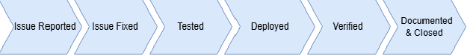

**Enhancement**:

A Definition of Done (DoD) for an **enhancement** is a shared, checklist-based understanding that a new feature or improvement meets all quality, functional, and organizational standards, rendering it fully shippable. For enhancements, it ensures the modification works within the existing system, has been tested, documented, and approved.

**DOD for Enhancement:**

* **Development:** The code is developed as per new feature requirement
* **Code Quality:** Code is checked in, reviewed by peers, and adheres to standards
* **Testing Passed:** Unit, functional, and regression tests pass to ensure no breakage of existing functionality.
* **Environment:** The enhancement is deployed in a staging/pre-production environment and passes user acceptance testing (UAT)
* **Documentation Updated:** Technical or user documentation is updated.
* **Closed in Tool:** The enhancement user story is updated and formally closed in the tracking system (e.g., Rally and SNOW)

Once the above DoD process is completed then it meets the customer/owner expectations.

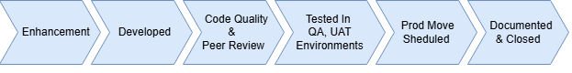

Report Metrics [Link](https://share.connect.aig/:x:/r/teams/GenAI/Shared%20Documents/Underwriting%20Co-Pilot/0%20-%20UW%20Assist%20Files/05-Production%20Stabilization%20Squad/Defect%20Metrics/Defect%20Metrics%20-%20Source%20Data.xlsx?d=wbf7a577d09dd47cfb03f306d40b2c983&csf=1&web=1&e=a3bVdA)

[Insert definition of done, ownership expectations, and reporting metrics]

# 8. Continuous Improvement

[Insert RCA process, feedback loops, and improvement actions]

### RCA Process

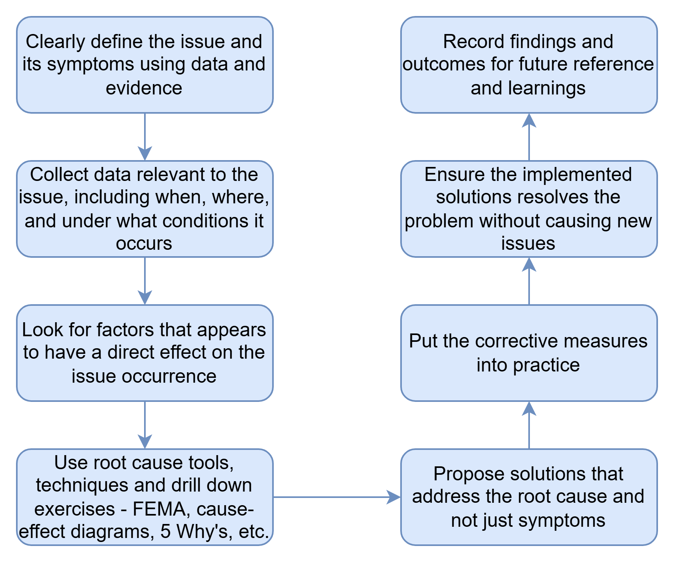

The analysis of root causes, along with preventive and corrective measures, is compiled into thematic trends and evaluated by the Product Stabilization Squad PO in collaboration with the other Product Owners, serving as design input for the Product Development Lifecycle.

The below presented is an illustration of the **Root Cause Themes** –

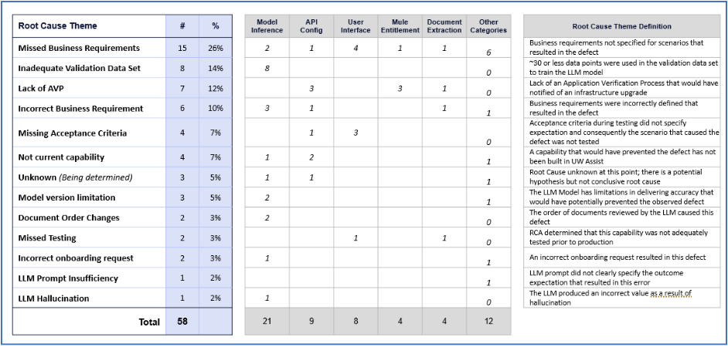

Root-causes and frequency of occurrence are shared with the Product PO’s periodically to use as input into design.

The following are the **top categories of the Root Cause Analysis** (listed in descending order based on their frequency).

* **Missed business requirement** for specific scenarios that resulted in the defect.
* **Inadequate validation data set** (~30 or less data points were used in the validation data set to train the LLM model).
* **Lack of an Application Verification Process** that would have notified us of a dependent infrastructure upgrade.
* **Incorrectly defined business requirement** that resulted in the specific defect.
* **Missing test acceptance criteria** that did not specify the expectation and consequently the scenario that caused the defect, resulting in inadequate testing.
* **LLM Model version limitation**, in that the LLM Model in use at the time has limitations in delivery accuracy that did not prevent the observed defect.

### Feedback Loops & Improvement Actions

Insights gained from defect management are communicated to the Product Team to enhance the reliability of Product delivery, assist in prioritizing critical areas of concern, and strengthen the product. This process is conducted in a systematic manner before the planning phase for a new PI. Additionally, these insights are utilized to guide the backlog of product features intended for development.

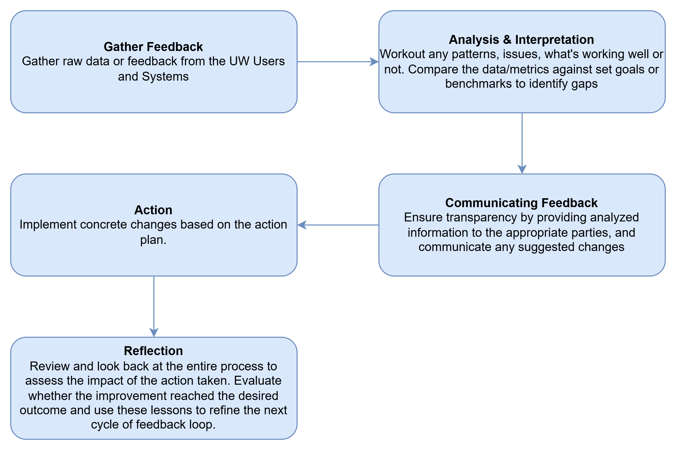

# 9. Metrics & Reporting

### **1. Metrics**

The following metrics have been established as measures of success for the management of Production Incidents in UW Assist.

|  |  |  |
| --- | --- | --- |
| Metric | Explanation | Formula |
| MTTR (Mean Time to Resolve) | The average time to restore normal operations from the moment an incident is reported or detected. | Total Downtime / Total Number of Incidents |
| SLA Adherence Ratio | The percentage of incidents resolved within the agreed-upon Service Level Agreement window. | (Number of incidents resolved within SLA targets / Total Number of Incidents) * 100 |
| Incident Volume | The total count of issues or outages recorded over a specific period. | Total Number of Incidents / Total Number of Submissions |
| Reopen Rate | The percentage of resolved incidents that are later reopened. | (Number of Incident Reopened / Total Number of Incidents) * 100 |
| High Severity Incidents | The ratio of high-impact incidents reported compared to the total incident volume. | (Number of S1 & S2 incidents / Total Number of Incidents) * 100 |
| Customer Satisfaction (CSAT) | The user given rating following an incident resolution. | (Number of Satisfied Customers / Total Number of Responses) * 100 |

### **2. Reporting**

The production stabilization team follows a structured reporting cadence to provide visibility into application stability, operational performance, and risk trends across supported line of business.

|  |  |  |
| --- | --- | --- |
| **Monthly Reporting** | Consolidated view of stabilization performance and recurring trends – it highlights incident patterns, root cause themes, and improvements. | <Link> |
| **Quarterly Reporting** | Executive-level view of application stability and operational maturity - focus is on trends, LOB onboarding outcomes, systemic issues, process improvements, and team effectiveness. | <Link> |

# 10. Appendices

### 1. Escalation Matrix

|  |  |  |  |  |
| --- | --- | --- | --- | --- |
| Severity | First Contact | Escalation Level 1 | Escalation Level 2 | Escalation Level 3 |
| 1 – Urgent | Product Analyst / Technical Lead | Product Owner (in 1 hour) | Engineering Manager / PMO (in 1.5 hours) | Product Leadership/ IT Service Owner (in 2 hours) |
| 2 – High | Product Analyst / Technical Lead | Product Owner (in 2.5 hours) | Engineering Manager / PMO (in 4 hours) | Product Leadership/ IT Service Owner (in 8 hours) |
| 3 – Medium | Product Analyst / Technical Lead | Product Owner (in 1 day) | Engineering Manager / PMO (in 2 days) | Product Leadership/ IT Service Owner (in 3 days) |
| 4 – Low | Product Analyst / Technical Lead | Product Owner (in 3 days) | Engineering Manager / PMO (in 4 days) | Product Leadership/ IT Service Owner (in 5 days) |
| 5 – Cosmetic | Product Analyst / Technical Lead | Product Owner (only during Weekly Connect/Prioritization) | Engineering Manager / PMO (only if extremely necessary) | Product Leadership/ IT Service Owner (only if extremely necessary) |

### 2. System Architectural

Below is the link to Application Architectures

* Financial <Link>
* Property <Link>
* Casualty <Link>

### 3. Templates

* Incident Report <Link>
* RCA <Link>
* Onboarding Checklist <Link>
* Lessons Learnt <[Link](https://share.connect.aig/teams/GenAI/_layouts/15/doc.aspx?sourcedoc=%7b608b109e-b6e6-4efc-8a12-991dbaa9ca13%7d&action=edit)>
* Known Error Database (KEDB) <[Link](https://share.connect.aig/teams/GenAI/_layouts/15/doc.aspx?sourcedoc=%7b608b109e-b6e6-4efc-8a12-991dbaa9ca13%7d&action=edit)>

### 4. Annexture

|  |  |  |
| --- | --- | --- |
| S.No. | Application | URL |
| 1 | Rally | <https://rally1.rallydev.com/slm/login.op> |
| 2 | Service Now | <https://aig.service-now.com/> |
| 3 | SailPoint | <https://identityiq.aig.net/identityiq/home.jsf> |
| 4 | Splunk | <https://aig-1.splunkcloud.com/en-US/app/launcher/home> |
| 5 | Palantir Foundry | <https://cyclamen.palantirfoundry.com/workspace/compass/home> |
| 6 | UW Assist – QA | [https://qa-genai.npgenaiapp.us-east-1.aws.aig.net](https://qa-genai.npgenaiapp.us-east-1.aws.aig.net/dashboard) |
| 7 | UW Assist – UAT | [https://uat-genai.npgenaiapp.us-east-1.aws.aig.net](https://uat-genai.npgenaiapp.us-east-1.aws.aig.net/dashboard) |
| 8 | UW Assist - PROD | <https://uwassist.aig.net> |
| 9 | SharePoint | [Link](https://share.connect.aig/teams/GenAI/Shared%20Documents/Forms/AllItems.aspx?e=5%3A3f0c9ad1775b484ca03c2d73cfe4d027&sharingv2=true&fromShare=true&at=9&CID=c7a9b590%2D26f3%2D444c%2Daf10%2D920000f9cc0e&FolderCTID=0x0120002FC3007F1BFF3A41B89E44C14E4E105E&id=%2Fteams%2FGenAI%2FShared%20Documents%2FUnderwriting%20Co%2DPilot%2F0%20%2D%20UW%20Assist%20Files) |
| 10 | Metrics | [Link](https://app.powerbi.com/groups/me/reports/0eb09371-3ac6-4b6b-95b6-619100a6aa73/1a14a116192b25823a6b?experience=power-bi) |

### 5. Glossary

The glossary provides definition of key terms and acronyms used in this playbook to ensure consistent understanding across business, delivery, stabilization, and support teams – [Link](https://share.connect.aig/:x:/r/teams/GenAI/Shared%20Documents/Underwriting%20Co-Pilot/0%20-%20UW%20Assist%20Files/05-Production%20Stabilization%20Squad/Process%20and%20Standards/Glossary.xlsx?d=wabf1906effb24678b434a451e7072157&csf=1&web=1&e=bIfXpo)